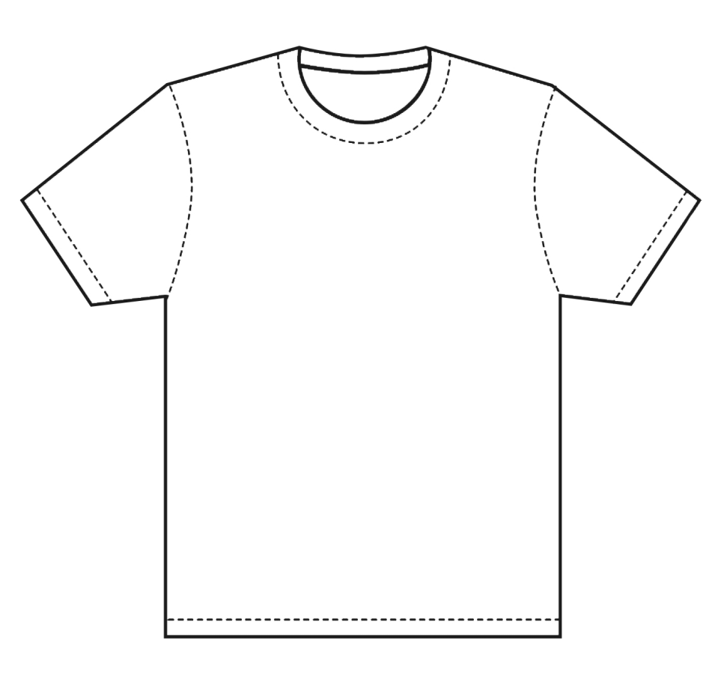

My pledge…



**#endpjparalysis #stayactive**



My pledge…



**#endpjparalysis #stayactive**



My pledge…



**#endpjparalysis #stayactive**



My pledge…



**#endpjparalysis #stayactive**